BYU-I Writing Center - https://www.byui.edu/academic-success-and-tutoring/writing

Chicago for the Humanities
The notes-bibliography style of Chicago/Turabian is commonly used in the humanities, history, and some social sciences. If you are unsure which style to use, ask your professor.

My Neighbor, The Holocaust:
Civilian Compliance With Nazis In Death Camp Border Towns

Jane Smith
HIST 341: The Holocaust
October 15, 2021

The title is placed 3 to 4 lines down from the top of the page, centered and bolded with the subtitle on the following line after a colon.

Give your name, the course title, and the assignment’s due date, leaving two blank spaces at the bottom of the page.
Course number followed by a colon and the course title must be present.
Provide the date in the shown format.

GENERAL RULES
- Double-spaced, except for block quotes, tables/figures, foot/endnotes, or the bibliography
- Use a readable and standard font, like Times New Roman 12 pt or Arial 10 pt
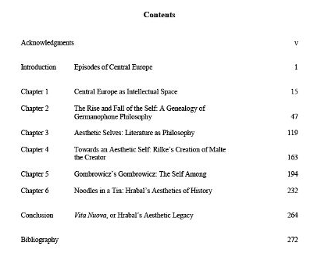
- 1-inch margins
- Page numbers can either be centered or flush right on either the header or the footer, but be consistent. Begin with 1 on your first page of written text. Do NOT number your title page and table of contents.

TABLE OF CONTENTS
A table of contents is only needed if specifically required by your professor and for assignments containing several chapters of writing. However, if required, your table of contents will look like this, with page numbers before your actual essay using Roman numerals.

SECTION HEADINGS
It is recommended that longer papers be separated into sections with headings. While Chicago style doesn’t demand specific types of headings/subheadings, the Chicago Manual of Style suggests the following style for each level.

Level | Format
1 | Centered, Bold, Title Case
2 | Centered, Regular Type, Title Case
3 | Flush Left, Italics, Title Case
4 | Flush left, regular type and case
5 | Begin your paragraph in a bold, short sentence. You then continue with your paragraph.
hi

BLOCK QUOTES
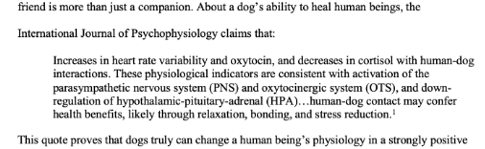
Long quotes need to be in their own paragraph as a single-spaced block with no quotations. Text of five or more lines and poetry of two or more lines need to be in a block quote introduced with a colon. Unless the quote marks the end of your paragraph (which isn’t recommended), continue your writing without an indent.

BIBLIOGRAPHY
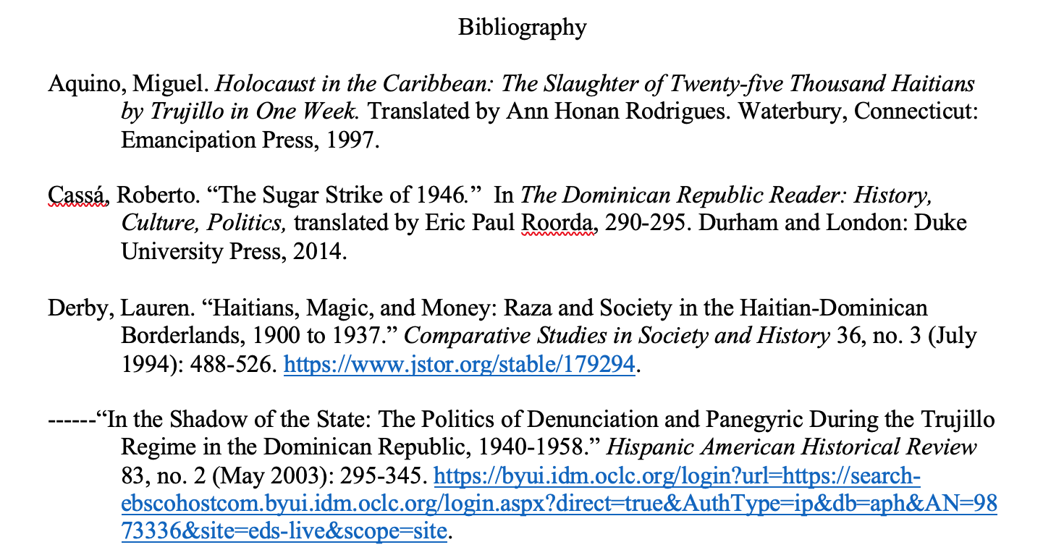
Your bibliography should include all of the sources you consulted, even ones you did not specifically cite. Bibliographies should follow these rules:
- Have their own page under the title “Bibliography,” unbolded and centered
- Use a single-spaced hanging indent with an extra space between each citation
- Be listed in alphabetical order based on the author’s last name
- End with a DOI if accessed online. If the DOI is unavailable, a working link or the name of the database the source was accessed on is okay.
- If an author is used multiple times, use six dashes in place of their name and organize their source alphabetically by the title of their paper, as shown.
- Website content, videos and podcasts, movies, social media content, the Bible and other sacred works, dictionaries, visual content (like paintings), and classical or medieval English literary works are only cited in the text unless they are frequently used or very important to your argument.

FOOTNOTES/ENDNOTES
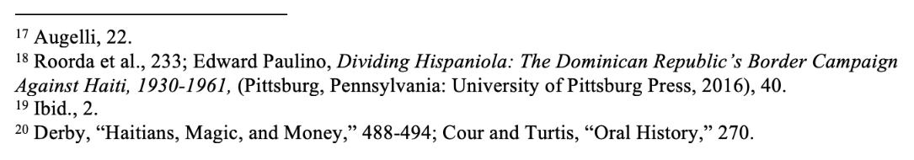
Sources referred to in the text of your paper are cited both in your bibliography and through foot or endnotes. Ask your professor if you are unsure which to do. Either way, to show the reader that you have used a source, at the very end of the sentence, after all punctuation, insert a foot/endnote marker. At the corresponding number at the end of the page, you would insert your citation.
Format
Foot/endnotes will be formatted similarly to your bibliography entry. However, there are a few basic rules.
- Have the author’s name listed as First Name Last Name
  - Like so: Liz Sharp, Title…
- Use commas to separate information instead of periods and put publication information in parentheses
- Be single-spaced, in the same font as the rest of the paper
- Some professors prefer notes to be slightly smaller than the rest of the text. When in doubt, ask.
- Full notes are only used once, and subsequent notes on the same source will simply be the author’s last name and page number. If the author has written more than one document that you are citing, the shortened citation would look like this: Author Last Name, “Shortened Title,” page.
- If you use the same source twice in a row, cite it as “Ibid.” If it is the same source, but on a different page, cite it as “Ibid., 7.” or whatever page the information is on.
- If you cite multiple sources in one sentence, connect them with a semicolon, as seen in the example notes after the number 20.
Types of Citations
This is how citations are formatted by type. The top example will be the full citation as listed in the bibliography, while the bottom is the full citation as listed in the notes the first time a source is used. “Date” asks for Month, Day, Year (as available). Page numbers in a citation are styled like 7-8, with no “pg.” or other abbreviation. “/” means “either or” and would not be included in your citation.
Book  (For books with multiple editions, include the edition after the title. Ex: Title of Book: Subtitle. 2nd ed. This is unnecessary for a first edition.) | Author Last Name, First Name. Title of Book: Subtitle. Translator/Editor’s First and Last Name. Place of Publication: Publisher, Date.  ¹ Author First and Last Name, Title of Book: Subtitle, trans./ed. by First and Last Name (Place of Publication: Publisher, Date), page number(s).
Chapter in a Book | Author of Chapter Last Name, First Name. “Chapter Title.” In Title of Book, edited by Editor First and Last Name, Page Range of Chapter. Place of Publication: Publisher, Date.  ¹ Author of Chapter First and Last Name, “Chapter Title,” in Title of Book, ed. Editor First and Last Name (Place of Publication: Publisher, Date), page(s).
Thesis/Dissertation | Author Last Name, First Name. “Title: Subtitle.” PhD diss., Publishing University, Place of Publication, Date. Website/Link.  ¹ Author First and Last Name, “Title: Subtitle” (PhD diss., Publishing University, Place of Publication, Date), page(s), Website Title/Link.
Journal Article | Author Last Name, First Name. “Title: Subtitle.” Journal Title Volume Number, Issue Number (Date): Page Range. DOI/Link.  ¹ Author First and Last Name, “Title: Subtitle.” Journal Title Volume Number, Issue Number (Date): Page Range, DOI/Link.
News/Magazine Article | Author Last Name, First Name. “Title: Subtitle.” Name of Newspaper, Date. Link.  ¹ Author First and Last Name, “Title: Subtitle,” Name of Newspaper, Date, Link.
Book Review | Author of Original Work Last Name, First Name. “Title of Review.” Review of Original Work Title, by Author of Review’s First and Last Name. Publisher of Review, Date Review was Published. Link.  ¹ Author of Original Work First and Last Name, “Title of Review,” review of Original Work Title, by Author of Review’s First and Last Name, Publisher of Review, Date Review was Published, Link.
Website Content  (Not cited in bibliography unless frequently used or very important) | Organization as Author. “Title of Page.” Title of Website. Date. Link.  ¹ “Title of Page,” Title of Website, Organization, Date, Link.
Videos and Podcasts  (Not cited in bibliography unless frequently used or very important) | Author Last Name, First Name. “Video Title.” Director/Producer Name. Date, Location, video, Timestamp. Link.  ¹ Author First and Last Name, “Video Title,” Director/Producer Name, Date, Location, video, Timestamp, Link.
Movies  (Not cited in bibliography unless frequently used or very important) | Director Last Name, First Name, director. Title. Studio, Year. Movie Length. Link.  ¹ Title, directed by First and Last Name, featuring Actors Relevant to Your Paper (Studio, Year), 0:01:00 to 0:02:00, Link.
Social Media Content  (Not cited in bibliography unless frequently used or very important) | Author (screen names acceptable). “First 160 Characters of Text Capitalized as in the Original.” Type of Post (or location, i.e., Facebook). Month, Day, Year (time stamp optional). URL.  ¹ Author (screen names acceptable), “First 160 Characters of Text Capitalized as in the Original,” Type of Post (or location, i.e., Facebook), Date (time stamp optional), URL.
Personal Communication  (Only cited as a note if not explicitly listed in text) | ¹ Other Person First and Last Name, type of communication, Month, Day, Year.
2-3 Authors | Author #1 Last Name, First Name, and Author #2 First and Last Name. Title…  ¹ Author #1 First and Last Name and Author #2 First and Last Name, Title…
4+ Authors  (List all authors in the bibliography) | ¹ Author #1 First and Last Name et al., Title…

