BYU-I Writing Center - https://www.byui.edu/academic-success-and-tutoring/writing

MLA Style 8th Edition

TITLE PAGE
Right-align your last name and the page number. Every page should have a header. To create changing page numbers, you must use the “Header” settings in your document.
Center the title. Do not bold or underline it.
Gray 1
Daniel Gray
Dr. Sloop
English 106
14 February 2020
Food Related Illness
In the restaurant business and in home preparation, one of the biggest threats to a food handler is food related illness. This threat can be prepared for with careful…
In the upper left-hand corner of the first page, list your name, the professor’s name, the class, and the date (with the date formatted as shown).
Double space the entire document, including the author name and assignment details.

GENERAL RULES

- Double-spaced & 1-inch margins
- Acceptable fonts include Calibri 11 pt, Arial 11 pt, Times New Roman 12 pt, and Georgia 11 pt.
- No additional space is needed before or after paragraphs
- Include a Works Cited page as a separate page at the end of your document by inserting a page break at the end of your actual writing. You can do this by searching “page break” on whatever writing application you use.

IN-TEXT CITATIONS
For summarizing, paraphrasing, quoting, or using other authors’ ideas.
Full Citation | List the author(s) last name and the page number the information is found on. | (Hunt and Gentry 42).
Divided Citation | If the author’s name is already in the sentence, there is no need to repeat it. | Thomas A. Maik states, “Women in marriage have prescribed roles” (35).
No Page | If your source doesn’t have page numbers, just list the author’s name. Do not list the paragraph number. | (Sloop).
No Author | Include the title in place of the author. | (“Existentialism” 2).
Author as Organization | If the author is listed as a group or corporation, list that as the author. | Cancer is bad (CDC 71).
More than 2 Authors | The first author’s name followed by “et al.” | (Miles et al. 26).
Poetry | Include the lines consulted. | He says, “The stricken flower bent double and so hung. / And still the bird revisited her young” (Frost lines 4-5).
Multiple Sources by the Same Author | Include the title of the work. | (Elkins, "Visual Studies" 63).
Authors with the Same Last Name | If there are authors of different sources with the same last name, include the first initial of each author in your individual citations. | (A. Miller 46).
Different Sources Used in the Same Sentence | If the information comes from multiple sources, you can list the sources in the order used in the text, separated by a semicolon. | …as has been discussed elsewhere (Burke 3; Dewey 21).
Time-based Sources | Include the time range referenced. Give space for hours, minutes, and seconds. | (00:02:31-00:03:22).

BLOCK QUOTES
Introduce the quote with a complete sentence and a colon.
For quoting 4+ lines from other authors.
Do not use quotation marks.
Don’t add extra space before or after the quote.
In The Hobbit, Tolkien uses descriptive language:
In a hole in the ground there lived a hobbit. Not a nasty, dirty, wet hole, filled with the ends of worms and an oozy smell, nor yet a dry, bare, sandy hole with nothing in it to sit down on or to eat: it was a hobbit-hole, and that means comfort. (Tolkien 1)
Tolkien used these words to pull the reader into the story…

Double-space the quote.
Start the block quote on its own line and indent the entire quote 0.5 inches from the left margin. To do this, highlight the quote and click the tab key on the keyboard.

Cite the source in parentheses after the quotation’s final punctuation.
Do not indent the next line following the quote.

WORKS CITED PAGE

A Works Cited page should follow these rules:
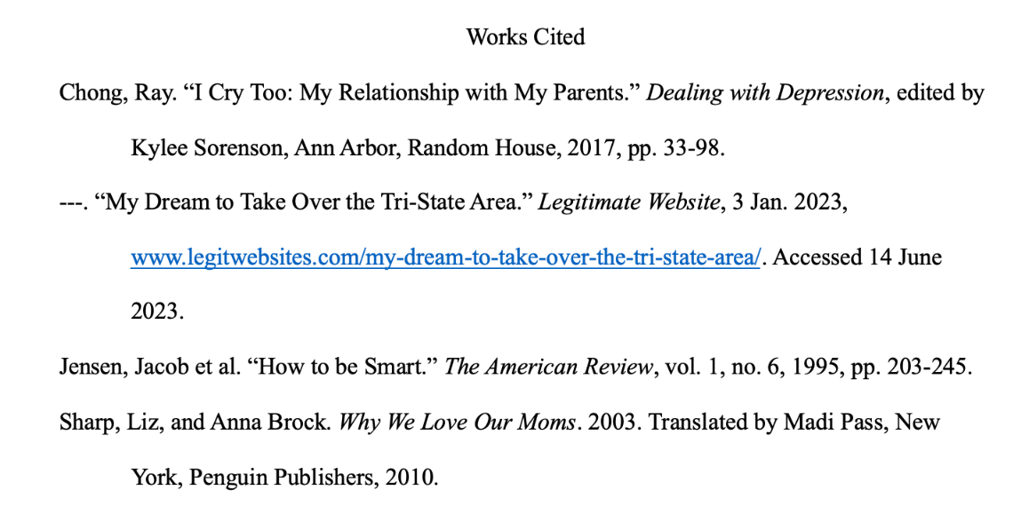
- Have the title “Works Cited” centered and unbolded at the top of the page
- Double-space with no extra space before or after new entries/paragraphs
- Keep the same font you’ve used throughout your essay
- Organize your citations in alphabetical order based on the first word
- Use a hanging indent for citations
- If there are multiple sources by the same author, use three hyphens in place of the author’s name
Note: Bolded text shows what exactly would be in your citation word for word (if applicable). Page ranges are formatted like “pp. 26-37,” while a single page is formatted like “p. 26.” If there is a link, include it at the end of the citation. If your source does not have something listed in the example citation, simply omit it.
Book (include edition number, volume number, editor, and translator as needed) | Author’s Last Name, First Name. Title of Book: Subtitle of Book. Edition number, translated by Translator’s First and Last Name, City of Publication, Publisher, Publication Year.  or  Author’s Last Name, First Name. Title of Book: Subtitle of Book. Edited by Editor’s First and Last Name, volume number, City of Publication, Publisher, Publication Year.
Republished Book | Author’s Last Name, First Name. Title of Book: Subtitle of Book. Original Publication Year. City of Publication, Publisher, Your Copy’s Publication Year.
A Work in an Anthology/ Book Chapter | Author of Chapter’s Last Name, First Name. “Chapter Title.” Title of Book: Subtitle, edited by Editor’s First and Last Name, City of Publication, Publisher, Publication Year, pp. page range.
Article in a Dictionary | “Title of Article.” Title of Dictionary. Edition number. Publication Year.
Thesis/Dissertation | Author’s Last Name, First Name. Title. Publication Year. University Name, PhD dissertation.  or  Author’s Last Name, First Name. Title. Publication Year. University Name, master’s thesis.
Journal Article | Author’s Last Name, First Name. “Title of Article.” Title of Journal, vol. number, no. number, Year of Publication, pp. page range.
News/Magazine Article | Author’s Last Name, First Name. “Title of Article.” Title of Newspaper, Day, Month Year, pp. pages.
Website Content | Author’s Last Name, First Name. “Title of Page.” Publisher Title, Day Month Year, URL. Accessed Day Month Year.
YouTube Video | “Title of Video.” YouTube, uploaded by Username, Day Month Year, URL.
Movies | Title of Movie. Directed by Director(s) First and Last Name, Film Studio, Distributor, release year.
Images | Artist’s Last Name, First Name. “Title of Work.” Title of Page, Publisher Title, Day Month Year, URL.
2 Authors | Author #1 Last Name, First Name, and Author #2 First and Last Name. Title…
3+ Authors | Author #1 Last Name, First Name et al. Title…
CORE ELEMENTS OF A WORKS CITED ENTRY

The citation elements are in the order in which they should appear in a citation. The final element used in a citation should end with a period.

Author | This is the person or organization primarily responsible for producing the work you focused on. Begin with the author’s last name, followed by a comma and the rest of the name, as presented in the work. End this element with a period.
Title of Source | The title is placed in quotation marks if the source is part of a larger work (a short story, a poem, a song). The title is italicized if the source is self-contained and independent (a collection of essays, a book, a scholarly journal). If a work can be self-contained, but is a part of a larger work, italicize both the work and its container. The title should also be followed by a period.
Title of Container | When the source being documented forms a part of a larger whole, the larger whole can be thought of as a container that holds the source. The title of the container is normally italicized and followed by a comma, since the information that comes next describes the container. Some sources have multiple containers (such as a scholarly journal article accessed through an electronic academic database).
Other Contributors | If their participation is important to your research or to the identification of the work, name the other contributors in the entry. Precede each name (or group of names) with a description of the role (such as “adapted by,” “directed by,” “translated by,” “edited by,” etc.)
Version | If the source carries a notation indicating that it is a version of a work released in more than one form, identify the version in your entry. Books are commonly issued in versions called editions.
Number | A text too long to be printed in one book is issued in multiple volumes, which may be numbered. Periodicals like scholarly journals use volumes and issue numbers. In general, the issues of a journal published in a single year compose one volume, with multiple issues within each volume. Include both the volume and issue numbers in your citation.
Publisher | The publisher is the organization primarily responsible for producing the source or making it available to the public. This could be a publishing company, a television producing company, a museum or university, a blog network, etc.
Publication Date | When a source carries more than one date, cite the date that is most meaningful or most relevant to your use of the source.
Location | In print sources a page number (preceded by a p.) or a range of a page numbers (preceded by pp.) specifies the location of a text container such as a book or anthology. The location of an online work is indicated by a URL or DOI. Other sources might require naming different kinds of locations; if you want to cite a painting you experienced first-hand at a museum, the museum’s name would be included as the location in this citation.

