BYU-I Writing Center - https://www.byui.edu/academic-success-and-tutoring/writing

Narrative and Personal Essays
Narrative essays are the twin to personal essays. They both go over personal experiences, true events, and both are subject to the author’s personal style of writing. However, just like twins, there are some major differences. Personal essays focus on reflection and self-discovery (see personal essay handout) whereas narrative essays focus more on just the story and bringing that story to life.

THE NARRATIVE STORY STRUCTURE
Narrative essays follow the same structure of storytelling as any other piece of literature. Here is a neat chart to show you the kind of rise and fall that should be happening. Keep in mind, this is just one way to write a narrative story, there are many structures.
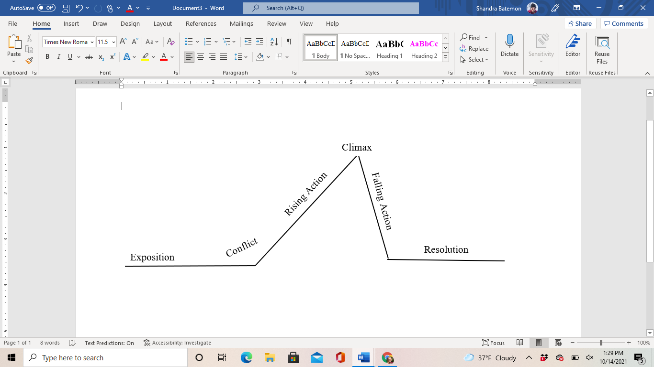
EXPOSITION
Exposition is the needed setting and background to start the story. This can be describing a place, a person, or even a feeling. The following example describes how one movie sets the scene by talking about the place where the story will happen.

Example:
In the Harry Potter series, the exposition is the setting of the scene on Privet Drive. We read about Albus Dumbledore and Minerva McGonagall dropping off baby Harry with the Dursleys. It sets a very whimsical and foreboding tone.

CONFLICT
Conflict is the main problem in the story. This is where the characters realize there is a challenge or issue they have to face. This answers the question “what happened in the story?”

Example:
The conflict in the first Harry Potter is that someone is trying to steal the Sorcerer’s Stone.

RISING ACTION
The events and actions taken that lead up to the climax.

Example:
Throughout Harry Potter and the Sorcerer’s Stone, Harry, Ron, and Hermione continue to discover suspicious activities pointing to a potential theft of a very powerful magical object. They begin making preventative plans.

CLIMAX
This is the part of the story that is the most dramatic--usually closer to the end of the story.

Example:
Harry, Ron, and Hermione face several very dangerous trials leading to the Sorcerer’s Stone. The story reaches its peak when Harry faces off with Voldemort for the first time.

FALLING ACTION
The falling action is the series of events that happens after the climax and leads into the resolution.

Example:
A great example of falling action is Dumbledore speaking to a recovering Harry at the hospital wing of Hogwarts. Harry made it through, school security is improving, and his friends are safe.

RESOLUTION
The ending! Wrap everything up nice and neat.

Example:
The house cup is rewarded, student exams are dismissed, and the trio of heroes head home for the summer the way they came: on the Hogwarts Express.

TOPICS
The other element for a narrative essay is that there needs to be an over all topic that moves the story along.
If you need any help brainstorming, you can ask yourselves some of these questions:

- What is something I’m passionate about? How did I become passionate about it?
- What is my greatest fear? When has that come into play in my life?
- Have I ever had to be brave? What motivated me to act on that?

PERSONAL ESSAYS
Personal essays explore a portion of the writer’s life. They focus on experiences and emotions, instead of a thesis you are trying to prove.

They are a close friend to narrative essays, but personal essays focus more on the personal reflection aspect and less on the immersive story.

WRITING EMOTION
One element that comes with personal essays is the liberal use of emotions and descriptions. When it comes to writing emotions, it’s best to use a good mixture of showing and telling.

SHOW
In writing, it is possible to be descriptive in a way that feels more like the reader is there experiencing it too. The following is an example of this type of writing.

Example: My hands shook as they ran through my hair for the 50th time in the last minute. My phone continued to vibrate as the two friends I had made in my calculus class texted the final exam questions, somehow unaware that this was considered cheating. My stomach churned with each chime and message, plunging me deeper into uncertainty.

TELL
Telling the reader directly what is happening or how you feel is also an option.

Example: I was anxious. The two friends that I had made in my calculus class were swapping the final exam questions over our group chat as I ate my dinner. I kept hoping it would stop, but they weren’t stopping. What do I do now?

Note: There is a common phrase used with these both, “show don’t tell.” It can be good to show instead of tell, but too much of either is annoying and neither is technically better. There needs to be a healthy balance of both.

INTRODUCTION
There are a few different ways you can start writing your personal essay. Use the back of this page to brainstorm some ideas based on the suggestions below:
- Describe the surroundings and setting
- Use dialogue
- Ask a question
- Make a statement (“Life is like a circus.”)

