ASBYU-I Writing Center - https://www.byui.edu/academic-success-and-tutoring/writing

Chicago for the Sciences
The author-date style of Chicago/Turabian is commonly used in the natural, physical, and some social sciences (like political science). If you are unsure which style to use, ask your professor.

My Neighbor, The Holocaust:
Civilian Compliance With Nazis In Death Camp Border Towns

Jane Smith
HIST 341: The Holocaust
October 15, 2021

The title is placed 3 to 4 lines down from the top of the page, centered and bolded with the subtitle on the following line after a colon.

Give your name, the course title, and the assignment’s due date, leaving two blank spaces at the bottom of the page.
Course number followed by a colon and the course title must be present.
Provide the date in the shown format.

GENERAL RULES
- Double-spaced, except for block quotes, tables/figures, or the reference list
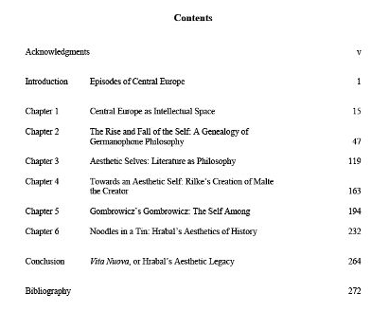
- Use a readable and standard font, like Times New Roman 12 pt or Arial 10 pt
- 1-inch margins
- Page numbers can either be centered or flush right on either the header or the footer, but be consistent. Begin with 1 on your first page of written text. Do NOT number your title page and table of contents.

TABLE OF CONTENTS
A table of contents is only needed if specifically required by your professor. If required, your table of contents will look like this, with page numbers before your actual essay using Roman numerals.

SECTION HEADINGS
It is recommended that longer papers be separated into sections with headings. While Chicago style doesn’t demand specific types of headings/subheadings, the Chicago Manual of Style suggests the following style for each level.

Level | Format
1 | Centered, Bold, Title Case
2 | Centered, Regular Type, Title Case
3 | Flush Left, Italics, Title Case
4 | Flush left, regular type and case
5 | Begin your paragraph in a bold, short sentence. You then continue with your paragraph.

BLOCK QUOTES
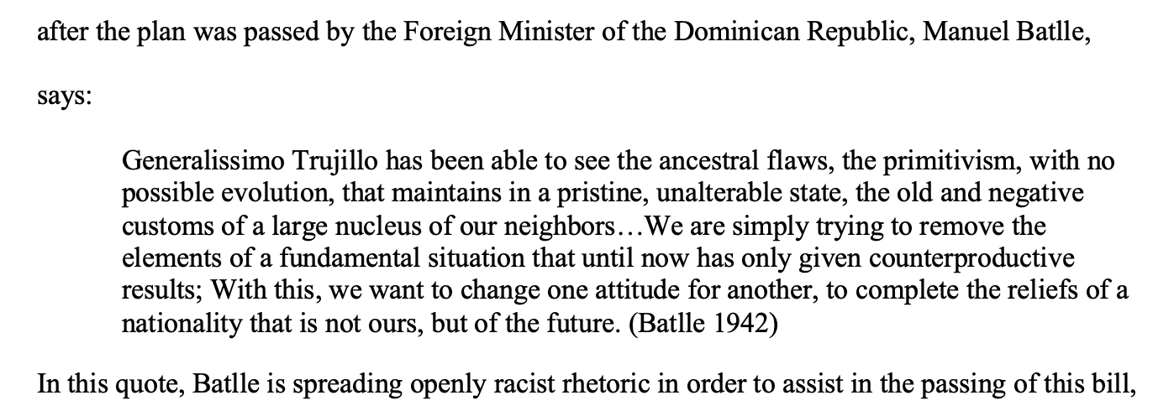
Long quotes need to be in their own paragraph as a single-spaced block with no quotations. Text of five or more lines and poetry of two or more lines need to be in a block quote introduced with a colon. Unless the quote marks the end of your paragraph (which isn’t recommended), continue your writing without an indent. For block quotes, your citation will go after the period.

IN-TEXT CITATIONS
In-text citations should be at the end of your sentence and will end with a period unless you mention the author’s name in text, which will be shown in the chart. Even if you do not directly quote a source, you need to have a citation at the end of any sentence that uses another writer’s ideas.

Citation Type | Instructions | Example
1 Author | Give the author’s last name, the year of publication, and the page number. | (Jensen 2019, 32).
2 Authors | Include both of the authors' last names in the same order they are listed in the source without commas | (Cheney and Vera 2005, 111-115).
3 Authors | Include all of the authors' last names in the same order they are listed in the source with commas | (Adams, Jacobs, and Chen 2011, 5-6).
4+ Authors | Only include the first author’s last name and the phrase “et al.” | (Schellenberg et al. 2022, 17).
No Author | Use a shortened title consisting of only the first four words of the title (omitting unimportant words like “an”) in place of the author, using either italics or quotation marks depending on what is needed in the full citation | (Account Operations Kent Family 1910, 63).  or  (“Great Trigonometrical Survey” 1863, 26).
No Date | Instead of a date, insert “n.d.” for “no date.” This also works on your reference page. | (Works n.d., 5).
No Page Number | Simply omit the number | (Goodman 1999).
Organization as Author | For publications issued by an organization (like certain magazines and newspaper articles), use the organization name as the author. | (American Bar Association 2016, 192).
Personal Communication (email, letter, texts) | Include the name of the other person, the type of communication, and the date. | (Emma Fenton to author, Instagram direct message, March 25, 2017).
Videos | Give the author’s name, the year, and when in the video the cited information is. | (Beyoncé 2016, at 1:09–1:24).
Social Media | If the author’s name is unknown, use the screen name as the author and omit the page number. | (Smosh 2016).
Author Mentioned in Text | Place the citation directly after you mention the author’s name | According to Gould (2007, 428), the song…
More Than One Work Cited | List all of the sources used in one sentence alphabetically in the parenthetical and separate them with a semicolon. If there are multiple works by the same author, only include the year and the page number. | (Armstrong 2003, 6; Beigl 2010; Pickett 2009, 17).  or  (Wiens 1989, 25; 1992, 6).

REFERENCE LIST
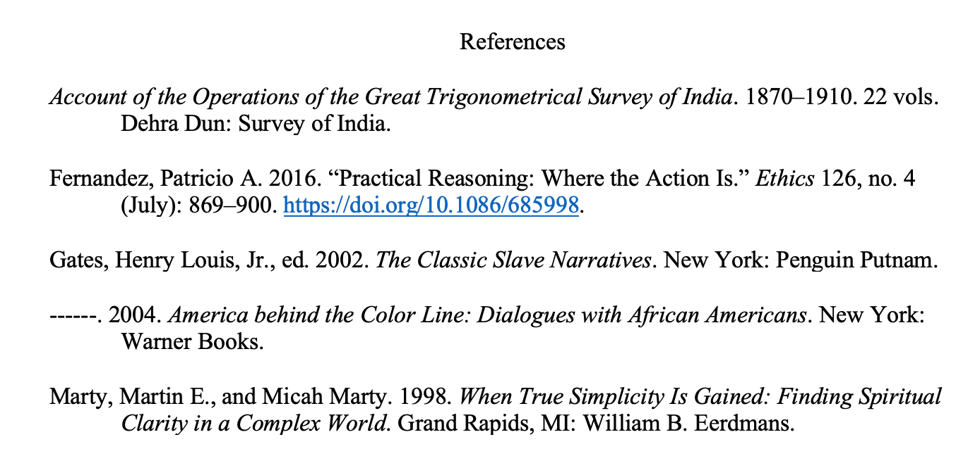
Your reference list should include all the sources you consulted, even those you did not specifically cite. Reference lists should follow these rules:
- Have a page titled “References,” unbolded and centered
- Use a single-spaced hanging indent with an extra space between each citation
- Be listed in alphabetical order based on the author’s last name
- End with a DOI if accessed online. If the DOI is unavailable, a working link or the name of the database the source was accessed on is okay.
- If an author is used multiple times, use six dashes in place of their name and organize their source chronologically from the date written, as shown.
- Website content, videos and podcasts, movies, social media content, the Bible and other sacred works, dictionaries, visual content (like paintings), and classical or medieval English literary works are only cited in the text unless they are frequently used or very important to your argument.
Types of Citations
This is how citations are formatted by type. Page numbers in a citation are styled like 7-8, with no “pg.” or other abbreviation. “YY-YY” stands for the page range. Bolded text shows what exactly would be in your citation. Exact dates would be formatted Month Day, Year (ex. March 1, 1999).
Book  (For books with multiple editions, include the edition after the title. Ex: Title of Book: Subtitle. 2nd ed. This is unnecessary for a first edition.) | Author’s Last Name, First Name. Year of Publication. Title of Book: Subtitle of Book. Translated by First and Last Name. Place of Publication: Publisher.  or  Author’s Last Name, First Name. Year of Publication. Title of Book: Subtitle of Book. Edited by First and Last Name. Place of Publication: Publisher. Link.
Chapter in a Book | Chapter Author’s Last Name, First Name. Year of Publication. “Title of Chapter: Subtitle of Chapter.” In Title of Book: Subtitle of Book, edited by Editor’s First and Last Names, Page Range of Chapter. Place of Publication: Publisher.
Thesis/Dissertation | Author’s Last Name, First Name. Year of Publication. “Title of Article: Subtitle of Article.” Master’s thesis, University. Link.  or  Author’s Last Name, First Name. Year of Publication. “Title of Article: Subtitle of Article.” PhD diss., University. Link.
Journal Article | Author’s Last Name, First Name. Year of Publication. “Title of Article: Subtitle of Article.” Title of Journal Volume Number, no. Issue Number (Month of Publication): YY–YY. URL.
News/Magazine Article  (If a source includes the publication location in the title ((ex. The New York Times)) or is an entirely online publication, omit the location. If it is international, include the country instead of the state.) | Author’s Last Name, First Name. Year of Publication. “Title of Article: Subtitle of Article.” Name of Newspaper (Publication City, State), Exact Publication Date. Link.
Book Review | Author of Review Last Name, First Name. Year. “Title of Review: Subtitle of Review.” Review of Book, by Book Author’s First and Last Name. Publisher of Review, Exact Publication Date of Review. Link.
Website Content | Author’s First Name, Last Name. Year. “Title of Page.” Title of Website. Last modified Exact Date. Link.  or  Title of Website. n.d. “Title of Page.” Accessed Exact Date. Link.
Videos and Podcasts | Author’s Last Name, First Name. Year of Publication. “Title of Video.” Exact Date of the Post. Type of Video, Length of Video. Link.
Movies | Director’s Last Name, First Name, director. Year. Title. Producing Company, Length of Movie. Link.
Social Media Content | Author’s Screen Name. Year of Publication. “First 160 characters of the post, capitalized as written originally.” Type of Post, Exact Date of Post. Link.
2-3 Authors | Author #1 Last Name, First Name, and Author #2 First and Last Name. Title…
4+ Authors  (List all authors in the bibliography) | Author #1’s Last Name, Author #1’s First Name, Author #2’s First and Last Names, Author #3’s First and Last Names, and Author #4’s First and Last Names. Title…

