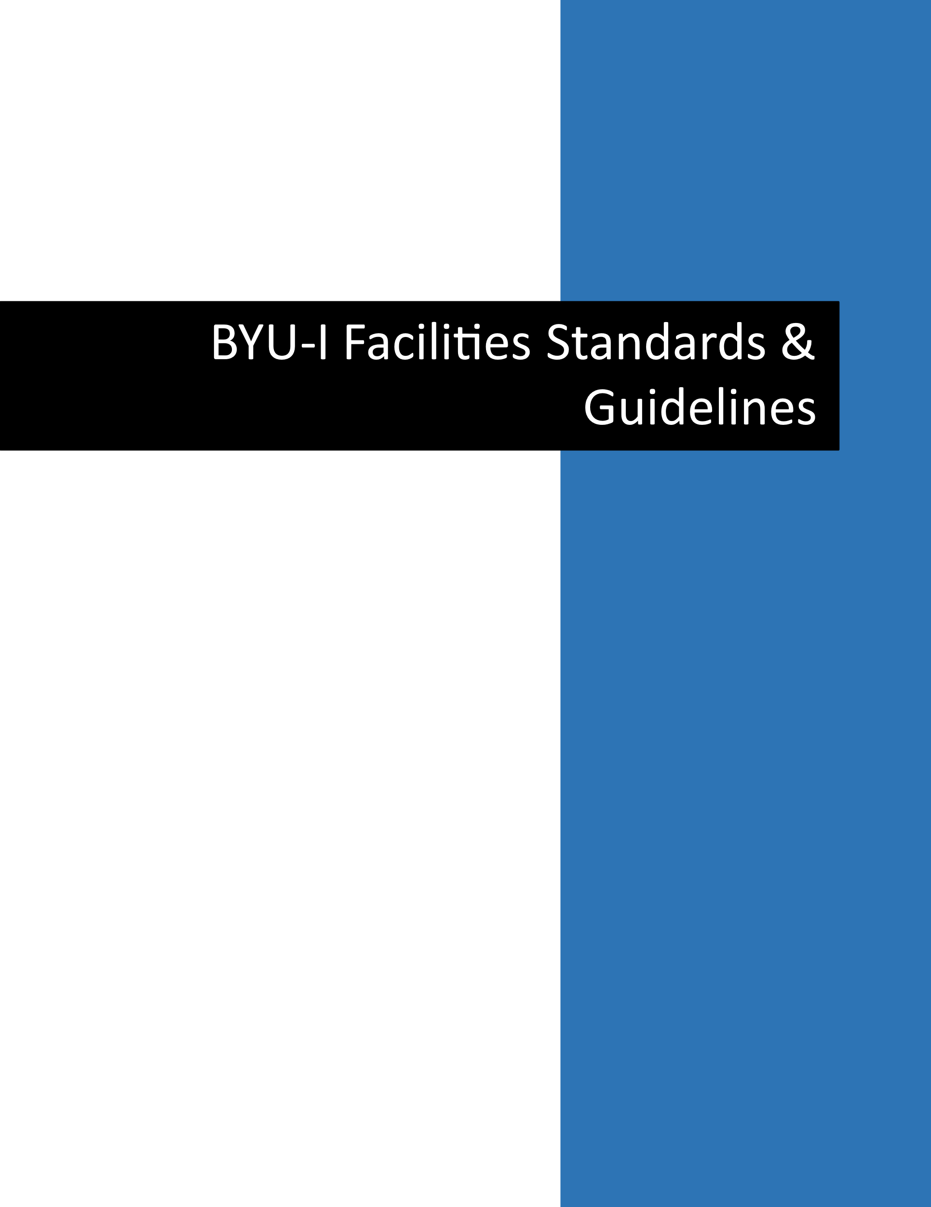

- OBJECTIVE
  - The BYU-Idaho Facilities Standards and Guidelines establish how University physical resources are to be furnished, maintained, and used. These standards support the Campus Furnishings Policy and the Space Stewardship, Assignment, and Modification Policy. Guiding principles to our purpose are:
- Supporting the mission of the University, Stewardship of University resources,
- Safety of students, employees, visitors, and other campus users,
- Support of the University identity through built environments that are clean, safe, harmonious, consistent, and appropriate for program needs.
- Compliance with applicable codes and regulations.
- STEWARDSHIP
  - The stewardship of BYU-Idaho’s University Operations Department (Facilities Management) is to provide and maintain a Campus (and other off-campus facilities) that supports the mission of the University. University resources are a sacred trust, and we strive to maximize the usefulness of and benefit from these resources. Campus standards are important in the following ways:
    - Focus on Value – Value is determined not just by initial cost but also by durability, efficiency, longevity, maintenance costs, and other life-cycle costs. Facility standards are set to maximize the value of physical resources.
    - Standardization – It is more efficient and cost-effective to maintain a smaller variety of finishes, fixtures, and equipment on campus. Facility standards reduce the University’s maintenance costs and allow more timely response to service requests.
    - Cleaning and Maintenance – Proper care of physical resources makes for a more pleasant campus experience and limits interruptions from unexpected repairs. Regular cleaning and standard maintenance and replacement schedules help avoid downtime due to unexpected failures.
    - Quality work – Standards that require installation, repairs, and other modifications to university facilities will be performed by qualified, trained, and authorized personnel to ensure a more attractive campus and help avoid unsafe conditions and accidents.
    - University Identity – Standard finishes, colors and materials create a harmonious and consistent environment that unifies and defines the campus.
    - Space Utilization – Most buildings, classrooms and offices on campus are used for multiple uses including academic, extracurricular, ecclesiastic and community use. Standards ensure that spaces are maintained so they function for all scheduled uses.
- STANDARDS COMMITTEE
  - Purpose & Responsibilities
    - The Standards Committee is responsible for maintaining and documenting campus standards, ensuring that all improvement and maintenance work done on campus meets established standards, and reviewing conditions and requests that do not meet approved standards.
  - Meetings
    - The Standards Committee meets regularly to discuss the following:
    - Updates and changes to standards including products, materials, finishes, and procedure compliance concerns, and issues
    - Requested exceptions to established standards
  - Approval of Exceptions
    - Requests or designs that do not meet approved standards must be reviewed before any work or changes are performed. Requests for exceptions to standards should be submitted through the appropriate University Operations request process and will be considered by the committee at the next scheduled meeting. Requesters will be notified of the committee’s decision within one week of the committee meeting.
  - Remediation of Non-Complying Conditions
    - When an existing condition does not meet an approved standard, the committee will either approve an exception to the standard or authorize and issue a work order to correct the condition. The cost of repairing or correcting a non-compliance may be charged to an individual or department after notifying the responsible party.
- REGULATORY REQUIREMENTS
  - City Fire Marshall
    - For safety reasons, all spaces on campus have maximum occupant limits. This limit is posted for many rooms, especially those in which large groups assemble. Whether the limit is posted or not, it is the responsibility of users to plan activities with occupancy limits in mind and ensure that limits are not exceeded. Contact the University Operations Safety office for more information.
    - Fire Suppression and Emergency Equipment
      - Fire extinguishers, defibrillators, and their cabinets must not be tampered with except in emergencies requiring their use.
      - Attaching, hanging, or adhering anything to fire suppression sprinkler heads, pipes, or any other system components is not permitted.
  - Doors/Windows
      - Doors with a closer device may not be propped open with a door stop except an electro-magnetic hold-open device that has been approved.
    - Windows - Interior windows in offices are typically only provided to allow daylight into spaces without windows.
  - Active Construction - Campus users must be approved to enter marked construction areas.
  - The Americans with Disabilities Act (ADA)
    - Accessible Routes
      - Code requirements prohibit placing obstructions, either permanently or temporarily, that would hinder accessibility to public spaces or evacuation in emergency situations. University users should not move furniture, fixtures, or equipment located in common areas or corridors, nor place any objects in corridors without approval. For more information, contact the Facilities Service Center (extension 2500).
  - Electrical panels shall have not have items placed in front maintaining a 3-foot clearance.
  - All users are responsible for maintaining clear access to exits, corridors, accessibility routes, fire protection equipment, and other life-safety systems. No item may be installed, stored, or displayed in a manner that creates a safety hazard or violates applicable codes or regulations.
- GENERAL STANDARDS
The following standards apply to all University facilities, workspaces, common areas, and campus users. These principles support the Campus Furnishings Policy and the Space Stewardship, Assignment, and Modification Policy and are intended to preserve safety, stewardship, consistency, and the appropriate use of university resources.

Authorized Modifications
    - Only Facilities-authorized personnel may install, remove, modify, or alter University-owned buildings, systems, finishes, fixtures, furniture, or equipment. Requests for modifications, reconfigurations, remodels, or non-standard installations must be submitted through approved Facilities processes and, when applicable, the University Operations project request process.

Surface Protection
    - To protect University property, tape, adhesives, tacks, pins, nails, screws, or similar attachment methods shall not be applied to walls, doors, windows, ceilings, furniture, or other building surfaces unless specifically approved by Facilities. Approved installations shall be performed by authorized personnel.

Personal Property
    - Personal property brought to campus is at the owner's risk. The University is not responsible for personal items that are damaged, lost, or stolen. Personal items must not create safety hazards, interfere with cleaning or maintenance, disrupt the intended use of a space, or conflict with University standards.

Appropriate Use and Appearance
    - All spaces, furnishings, artwork, decorations, displays, and personal items should reflect good taste and be consistent with Church and University standards. Materials that are offensive, disruptive, unsafe, or inconsistent with the University's mission may be removed.
- CAMPUS SPACES
  - Use of University Spaces
    - All areas of campus, both interior and exterior, are primarily used for approved University purposes and events scheduled by ecclesiastic units assigned to the campus. Community events, such as local school graduations, youth group activities, wedding receptions, etc. must be approved and scheduled through the Scheduling Office.
    - All users of common or scheduled spaces must clean up after themselves and return chairs and other movable furniture to their proper locations. Classroom chairs, tables and desks not fixed to the floor or walls may be moved within the classroom if they are returned to their proper location. Furniture may not be removed from any room or area except by Facilities Services personnel. For requests to move furniture or to schedule furniture setup for large event rooms contact the Service Center at ext. 2500.
  - Standard Offices
    - Standard Furnishings May Include:
      - Work surface, Storage (files, pedestals, shelving as needed), Office chair, Guest seating, Whiteboard, Task lighting, and Window coverings
      - Standard Office Shelving is limited to 60 linear feet. Items stored on shelving must maintain a clearance distance of 18 inches from the top of the item to the ceiling.
      - Personal furniture (including but not limited to sofas, day beds, recliners, bookshelves, and love seats) are prohibited in employee offices and throughout campus.
    - Furniture – The University uses Steelcase furniture as standard furniture for all offices. Refer to the Design & Construction Standards for layout and styles. Additional furniture provided by the occupant, department, or taken from other campus locations is not permitted in offices
    - Sit-to-Stand Desk - Sit-to-stand desks are not part of the default furnishing standard.
      - Sit-to-stand desks may be approved only when:
        - Supported by a documented ergonomic or medical need, OR Required for a clearly defined job function
        - Ergonomic accommodation such as sit/stand desks requests are evaluated through the university's established accommodation processes.
    - Televisions – Televisions, regardless of how or by whom they are purchased, are not permitted for permanent installation in individual offices. Exceptions must be approved by a Vice President and the University Operations Managing Director.
    - Graphics, text, or messages may not be placed or displayed from windows. See 7.2.4
    - Air fresheners or other fragrances that can be smelled from outside the office may not be used.
    - Candles, or any items that produce smoke or flame are prohibited.
    - Electric fragrance heaters may not be used anywhere on campus.
    - Pets, including fish in bowls or aquariums, may not be kept in, or brought to personal offices.
    - Ecclesiastical Use – Many individual offices are also used by ecclesiastical units after hours and on weekends. All offices, whether currently assigned for ecclesiastical use or not, must be kept in a condition that is consistent with and conducive to ecclesiastical use. Personal and work items left on desks may be moved by ecclesiastical leaders, clerks, or visitors. If an office occupant is concerned about confidentiality or potential damage to personal or work items, they should secure them before leaving the office at the end of each day. Other personal items, artwork, décor, etc. that would be inappropriate or distracting to participants in an ecclesiastical meeting or interview should not be placed in offices.
    - Cleaning – Basic cleaning and trash removal in offices is routinely performed by Facilities Services personnel. Occupants are responsible for daily care of their offices, keeping work surfaces and floors clear enough for routine cleaning, promptly removing clutter or spills, and maintaining spaces in a clean and orderly condition consistent with ecclesiastical use.
  - Reception Areas
    - Reception areas for academic departments or administrative offices are furnished using standard furniture systems and components. While configurations vary widely depending on needs and available space, it is intended that fixtures, finishes, and overall feel are uniform across campus. Refer to the Facilities Design Standard for alteration requests.
  - Circulation Areas
    - Areas immediately outside academic or administrative offices should not be considered extensions of the office area. Anything affixed to corridor walls or placed in circulation areas without proper authorization may be removed and disposed of by Facilities without notice or compensation. These areas are not to be modified except by an authorized Facilities employee.
    - Whiteboards are not permitted in corridors.
- ARTWORK AND GRAPHICS
    - No individual, department, or office may place artwork in common areas or classrooms without approval from the art gallery curator and/or University Communications.
    - All artwork on campus must follow art gallery standards. Contact the Art Gallery Curator for more information.
  - Artwork in Individual Offices or Department Office Suites
    - Artwork hung on office walls should be limited to 5 items. Additional artwork should be freestanding.
    - Artwork must be in good taste and appropriate for ecclesiastic uses whether the space is scheduled for ecclesiastic use or not.
    - Artwork on walls should be framed or in a condition suitable for permanent display. Unframed posters or other unmounted works are not approved.
    - Wall graphics and vinyl lettering are not permitted in offices, classrooms or circulation areas outside department offices. Any graphics or vinyl lettering must be approved by University Relations and Facilities. Framed art, posters, etc. should not be hung in classrooms.
  - Event Notifications
    - Posters, flyers, notices, advertising, and other unframed printed material may only be attached to bulletin boards or tack strips approved and installed by Facilities. Use of tape, adhesives, tacks, pins, etc. on other surfaces is not permitted. University Communications approves and posts content attached to bulletin boards, tack strips, and other displays in corridors, lobbies, and other common areas. Unapproved materials in common areas will be removed and discarded without notice or compensation. Contact University Communications for more information.
  - Walls
    - Artwork and graphics applied to walls must comply with General Standards: Surface Protection and Authorized Modifications. Contact the Service Center for installation assistance.
  - Windows and Other Glass Surfaces
    - Graphics, signage, and lettering are generally not appropriate on glass windows, doors, storefront, and other glass surfaces. See 7.2.4
    - Windows are not approved to be used as marker boards and should not be covered.
  - Doors
    - Door signage and attachments must be approved by Facilities and comply with General Standards: Surface Protection.
- OTHER
  - Furniture
    - University Operations, through Facilities Management, is the steward of all furniture on campus. Furniture should not be purchased or provided by other departments or individuals without approval by the Standards Committee. Refer to the Design & Construction Standards for process and project request. Approved furniture purchased or provided by departments becomes part of the university furniture inventory and is subject to Facilities stewardship.
  - Painting - Where approved accent wall paint is allowed (one wall in reception areas and conference rooms, and in common areas as determined by Facilities) and that it isn’t permitted in offices. Painting is performed by Facilities.
  - Appliances and Equipment
    - Refrigerators and microwave ovens are approved by the University and procured by Purchasing. They may be approved in office suites and break rooms for use by students and employees. They are prohibited in building corridors.
    - Personal appliances in private offices, such as personal refrigerators, ice makers, beverage heaters, and microwave ovens, must be approved by Facilities. Requests for appliances can be initiated through the Service Center at ext. 2500.
    - Use of food preparation appliances that generate heat, such as griddles, grills, and hot plates are permitted for occasional special events with Fire Safety Officer approval. Care should be taken when using any appliance to avoid creating smoke or strong odors.
  - Personal Heaters
    - See Policy Library - Space Heaters
  - Open Flame
    - Open flame of any type, except when approved by University Fire Safety Officer, is not permitted on campus.
  - Personal Items
    - All Personal and Department offices should be kept in a clean and orderly state. Personal items may be placed in offices if they are not vulgar, offensive, inconsistent with Church or University standards, disruptive to the office's function or adjoining areas, or prominent when viewed from outside the office. Items may not accumulate in a way that interferes with cleaning, maintenance, accessibility, egress, safety, or the intended use of the space. Facilities Management may require reduction or removal of clutter when necessary.
See General Standards for Surface Protection and Personal Items.
    - Facilities Management may require removal of any item that poses risk or exceeds circuit capacity.
  - Decorations
    - Temporary decorations for events, holidays, etc. should be modest, in good taste, in harmony with Church and University standards and teachings, support the intended use of the space, and be removed promptly after the event or season. Decorations should comply with the following conditions:
    - Anchors that penetrate or otherwise damage a building surface should not be used except as approved and installed by authorized Facilities personnel. See Section 7 “Artwork and Graphics” for more information. Gaffer’s tape may be used for applications of less than 24 hours. Contact the Service Center for assistance (extension 2500).
    - Decorations should not attach to or obstruct light fixtures, exit signs, fire extinguishers, defibrillator cabinets, sprinkler heads, wayfinding signage, or emergency notification devices.
    - Decorations in corridors or other egress routes should not be placed on floors or protrude more than 4” from wall surfaces.
    - Powered decorations, power cords, and extension cords must be UL-listed and should not cross floor surfaces or hang where they could be a tripping or snagging hazard. Cords should not cross pedestrian traffic, even when taped or covered. Decorations should be located so visible, exposed power cords are 6 feet or less.
    - Easter and Christmas decorations should focus on the Savior and remain modest and appropriate for the space.
- SERVICE, REMODEL & MODIFICATION REQUESTS
  - Limitations on Modifications
    - Employees may not alter their office or workspace, including reconfiguring layout or furniture placement, removing standard furnishings, installing non-standard furniture, or modifying walls, ceilings, lighting, or finishes. Requests for exceptions or modifications must be processed through the appropriate University Operations request process and, when applicable, reviewed under the Space Stewardship, Assignment, and Modification Policy.
  - Service Requests
    - To make a custodial, maintenance, or repair request for campus, housing, agricultural science center, or KBI transmitter, visit the University Operations website at https://www.byui.edu/university-operations/. Select “Service Requests” and enter the requested information.
  - Project Requests
    - See “Design & Construction Standards”

