BYU-I Writing Center - https://www.byui.edu/academic-success-and-tutoring/writing

Prewriting & Writer’s Block
All writers, even professionals, feel stuck in the mud with their writing at times. This is normal and should not lead you to the conclusion, “I’m just not a very good writer.” The following tips will help get you unstuck.

ELIMINATE DISTRACTIONS
First and foremost, get rid of distractions and clear your mental and physical space. Close all social media apps. Put your phone in a different room. Turn off (or at least down) the music. Shut the door, and let others know you need some time without interruptions. Clean up your work area; a cluttered desk can result in a cluttered mind. Also, avoid writing when you are too tired or hungry.

PRAY FOR CLARITY
“And by the power of the Holy Ghost ye may know the truth of all things” (Moroni 10:5). Start by asking in prayer for help and enlightenment on your topic, and then listen for those subtle ideas and promptings from the Spirit. Often, using some of these brainstorming techniques gives the Spirit the vehicle and time to inspire you.

FREE-WRITE
When you free-write, let your thoughts flow, putting pen to paper and writing down whatever comes into your mind—no internal judgments, no editing. Just let it all out.
- Use a timer, and keep putting words down until it stops.
- Ask yourself prompting questions: Why did I choose this topic? What does it mean to me? Why does it matter? How have I come to believe the way I do?

MAKE LISTS
Another tactic is using lists that help you gather more perspective on the topic. Try making lists on any of these:
- Possible topics
- The general topic
- Sequence of events or argument
- Main points for your topic

Gather Materials

Before trying to force words onto the page, take time to collect useful materials like sources, quotes, notes, or even random ideas related to your topic. This process helps you build a foundation so you are not starting from nothing. Looking through your materials can spark new connections, remind you of your main purpose, and reduce the pressure to come up with ideas on the spot. When your brain has something concrete to react to, writing often feels more natural and less overwhelming.

USE A WEB & CLUSTER
Do you remember those brainstorming webs you made in elementary school? Your teacher would have you circle your topic in the middle and branch off with lines leading to ideas. Well, you can still use that as an adult! It is typically a very efficient way to brainstorm.

Once you have created the web, you can cluster some of the ideas together into main points. If one main point isn’t strong enough, you can toss it or use it to support one of your other main points.

Example:

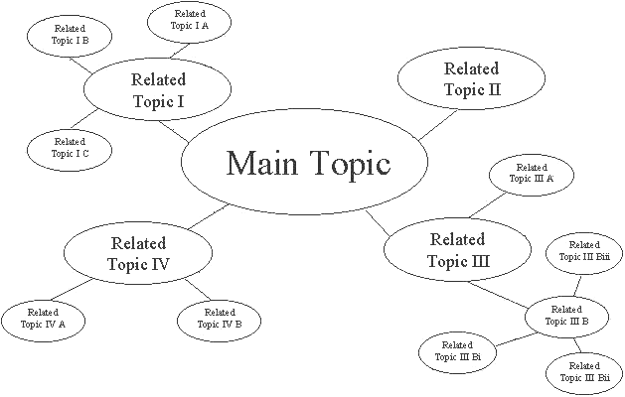

GET CREATIVE
- Carry a notebook everywhere and write down your observations.
- Put your ideas on notecards.
- Use graphs or charts to organize your ideas.
- Discuss your ideas with a friend or a tutor.

WRITE A “MINI” VERSION OF YOUR PAPER
After you have your rough outline, brainstorming, and thesis done, try writing a miniature version of your paper. Imagine that your assignment is actually a fraction of its actual size, and write a short draft.

TAKE A BREAK
Give your mind a rest. If you feel yourself getting angry or frustrated with your writing, just walk away and take a break. Do something else for a while—something enjoyable—and then come back to your project with fresh eyes and a relaxed mind.

